Three-Dimensional Modeling Environment “Claymore” Based on Augmented Direct Manipulation Technique
Takashi Oshiba and Jiro Tanaka
University of Tsukuba 1-1-1 Tennodai Tsukuba Ibaraki 305-0006 Japan e-mail: {ohshiba, jiro}@softlab.is.tsukuba.ac.jp

Augmented Manipulation
Direct manipulation is the operation in which users' operations directly invoke the reaction of the system (Shneiderman 1986). We apply the direct manipulation technique to operate a three-dimensional object. Some works on editing a three-dimensional object by using the direct manipulation technique have been proposed. But they require a special input device. We think it is beneficial to make users be able to manipulate a three-dimensional object without using a special input device. We use the mouse as our input device instead of using the special input device. We have implemented a system in which users can manipulate a three-dimensional object by using a mouse.
When users manipulate a three-dimensional object, they have the difficulty to specify the position of the object because the input device is two-dimensional. When they operate the three-dimensional object, there is a lack of information because the display of a computer is two-dimensional. Applying conventional direct manipulation to operate the three-dimensional object is not sufficient to ease this difficulty.
To solve the problems, we propose “augmented manipulation” which is an enhanced direct manipulation technique by using additional information (Mitsunobu, Oshiba and Tanaka 1998, Tanaka, Mitsunobu and Oshiba 1998). We use the following objects to represent the additional information (Figure 1).
- Ground
- Shadow
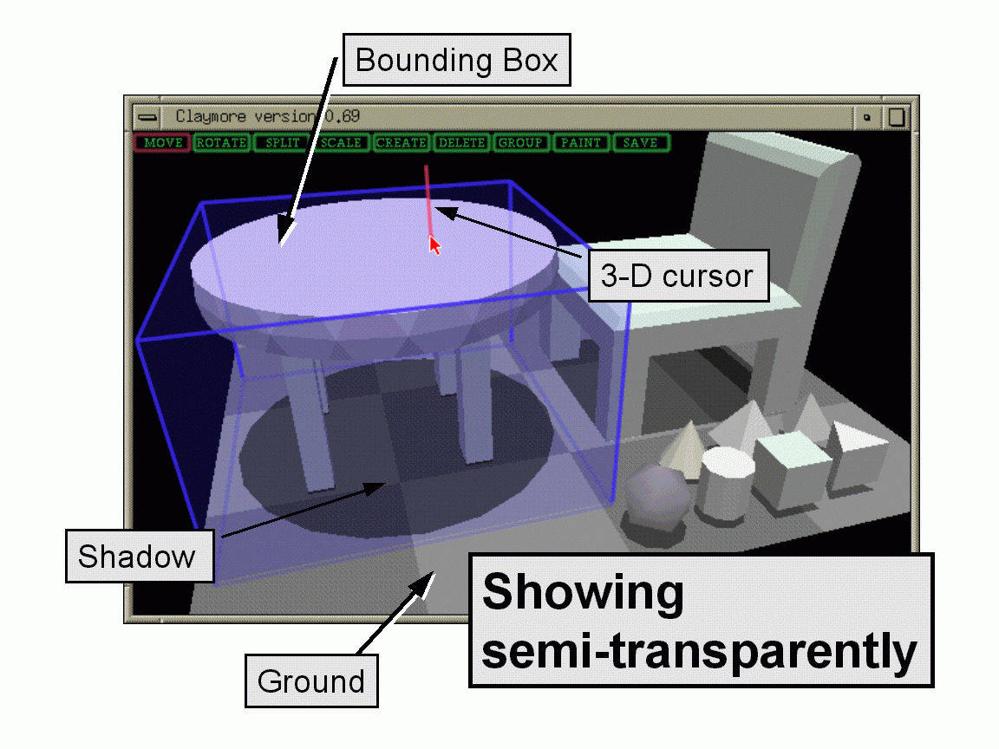
- Three-dimensional cursor
- Bounding box
Figure 1: The additional information.
We show all the additional information semi-transparently. When an object overlaps with additional information, showing the additional information semi-transparently is more effective (Rekimoto 1993). Users are able to operate three-dimensional objects easily with the help of the additional information.

Modeling Paradigm of “Claymore”
Users can construct a three-dimensional model (for example, we can make a table object) by following steps (Figure 2).
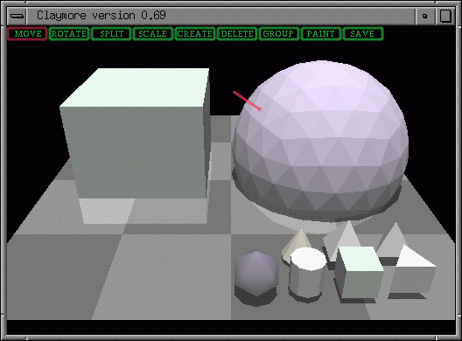
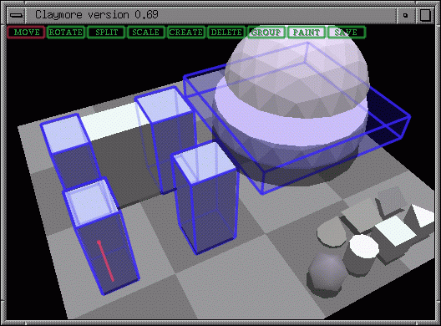
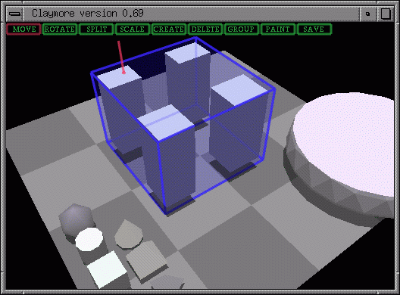
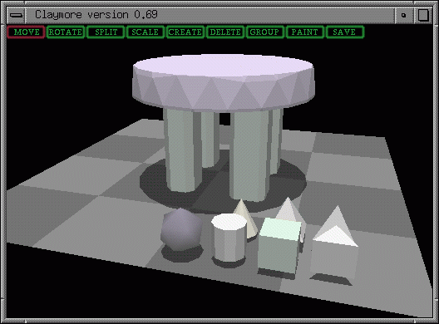

Figure 2: The modeling processes of a table object.
- Creating a fundamental object.
We prepare the following miniature objects as fundamental models: sphere, cylinder, cone, cube, square pyramid, triangular prism and tetrahedron. The miniatures of these models are placed as three-dimensional icons. When users click one of the miniatures, the model appears in the center of the window. Its shape corresponds to its original model.
In this step, we construct a cube and a sphere (the upper left of Figure 2).
- Constructing parts by cutting and deleting.
Users can quarry parts from the fundamental objects by using the cutter plane. Users can move the cutter plane by moving a mouse. When the cutter plane cuts the object, the object is split into two parts. Users can delete the unnecessary part and leave the necessary one.
In this step, we make the circular board of the table by cutting the sphere twice. We make the four legs of the table by cutting the cube (the upper right of Figure 2).
- Grouping the parts.
The parts can be combined by grouping the parts. More than one object can be selected to form a group. When users select an object by clicking the mouse button, the bounding box of the object appears. The bounding box for the group of selected objects is constructed by combining the bounding boxes of each object in the group. The group of objects can be manipulated as one combined object.
In this step, we combine the four legs of the table (the lower left of Figure 2).
- Arranging the parts by moving and rotating.
In this step, we arrange the circular board of the table and the four legs of the table and put them in appropriate places (the lower left of Figure 2).
- Saving the model.
The modeling data of the objects can be stored in VRML format or alternately in Wavefront OBJ format.
Repeating step 1 ~ 4, users can construct the more complex objects.

The Functions of “Claymore”
We have implemented the following functions: Move, Rotate, Cut, Deform, Create, Delete, Group, Paint and Save.

Objects connected by a joint
In addition to the functions mentioned above, “Claymore” provides a joint through which two objects can be connected (Figure 3). The joint is represented semi-transparently. The joint is also three-dimensional object in “Claymore.” The shape of the joint object is like a stick. When two objects are connected, the objects can be pivoted on the joint object with mouse operation. Users can control the posture of the pivot by rotating the joint object itself.
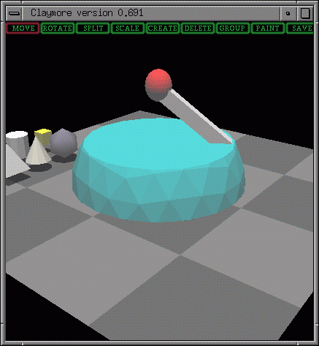
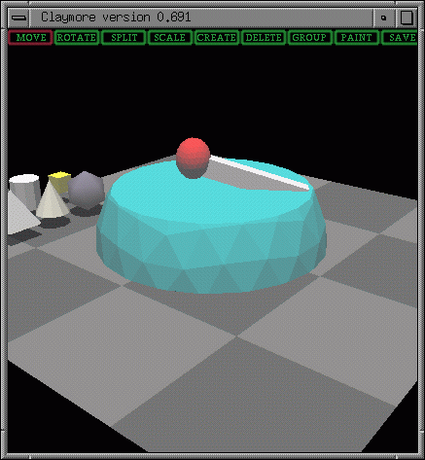
Figure 3: Objects connected by a joint.

Discussions
Users cannot construct three-dimensional objects easily when they use conventional three-dimensional modeling tools or three-dimensional CAD tools. We focus on the easiness to construct three-dimensional objects. “Claymore” is the environment which is like the three-dimensional version of “MacDraw.” Users can construct the three-dimensional model easily by using “Claymore.” The three-dimensional model can be exported to other three-dimensional applications. The format of the three-dimensional model is VRML format or alternately Wavefront OBJ format.
In fact, the three-dimensional models constructed by “Claymore” are used by “A.T”(Actors Theatre). “A.T” is a real-time three-dimensional animated system implemented by the Taki group, Kobe University in Japan.
Although users can construct a simple shaped model, it is relatively difficult to construct a complex one. Our future work is to implement more powerful techniques for constructing more complex objects.

Related work
Michael Chen et al. (Chen 1988) evaluated the method of rotation in a three-dimensional space by using a mouse. They proposed the method of rotation by using a virtual sphere controller. Our rotation method is different from their approach because users can rotate an object directly without using the virtual sphere controller.
Robert C. Zeleznik et al. (Zeleznik 1996) proposed a direct manipulation technique for operating a three-dimensional object. Their technique has been implemented in their three-dimensional modeler “SKETCH” which uses a pen as a two-dimensional input device. Our modeler “Claymore” is different from their approach because “Claymore” does not use a special input device such as a pen.

Summary
We apply the direct manipulation to operate a three-dimensional object. We propose “augmented manipulation” which is an enhanced direct manipulation technique by using additional information. We implement the three-dimensional modeling tool “Claymore” by using this technique.

Reference
Ben Shneiderman: Direct Manipulation: A Step Beyond Programming Languages, IEEE Computer, Vol.16, No.8, pp.57-69, 1983.
Jun Rekimoto: The Information Cube: Using Transparency in 3D Information Visualization, Workshop on Interactive Systems and Software I (WISS'93), pp.1-8, September, 1993 (in Japanese).
Hideki Mitsunobu, Takashi Oshiba and Jiro Tanaka: Claymore: Augmented Direct Manipulation of Three-Dimensional Objects, In Proceedings of Asia Pacific Computer Human Interaction 1998 (APCHI98), pp.210-216, July, 1998.
Jiro Tanaka, Hideki Mitsunobu and Takashi Oshiba: Claymore: Three-Dimensional Modeling Tool, In Proceedings of The 20th International Conference on Software Engineering (ICSE98), pp.67-72 (Volume II), April, 1998.
Michael Chen et al.: A Study in Interactive 3-D Rotation Using 2-D Control Devices, ACM SIGGRAPH Computer Graphics, pp.121-129, August, 1988.
Robert C. Zeleznik et al.: SKETCH: An Interface for Sketching 3D Scenes, ACM SIGGRAPH Computer Graphics, pp.163-170, August, 1996.

